OSSP (Operating Systems And Systems Programming) - 25CS2104E
(SKILL Content Delivery Concepts)

SKILL 4A :
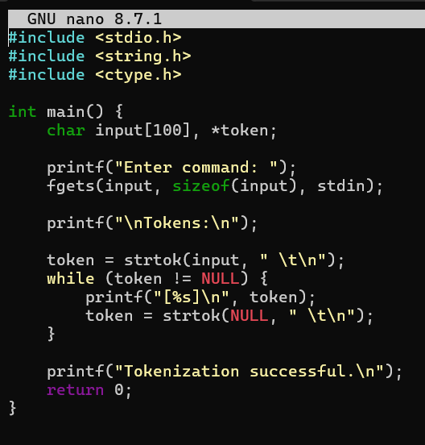
Output :
